Zip A Dee Doo Dah by Ray Gilbert & Allie Wrubel
Recorded by James Baskett, 1945
From the Walt Disney movie "Song of the South"
Academy Award winner, 1946, best song

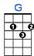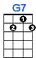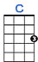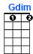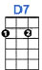

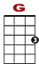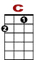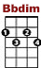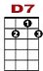

3 0 0 3 3 0
0 1 2 3 1 3 3 0 0 0
0 0 2

Zip a dee doo dah, zip a dee ay, my, oh my____, what a wonderful day!

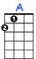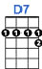

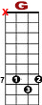

3 0 0 0 2 3 7 5 0 2 3
0 1 2 3 1 3 8

Plenty of sunshine headed my way, zip a dee doo dah, zip a dee ay.

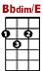

3 0 2 0 0 2 3 5 7 5 2 3 2 0
1 3 8 3 1 0
2 2

Mister bluebird on my shoul - der. It's the truth, it's actual. Everything is sa-tis-fac-tual.

3 0 0 0 2 3 7 5 0 2 3
0 1 2 3 1 3 8

Zip a dee doo dah, zip a dee ay Wonderful feel-in', wonder - ful day.

