You Belong to Me by Pee Wee King, Chilton Price and Redd Stewart

1st VERSE:
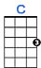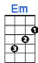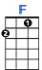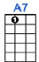
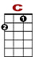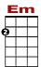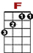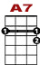
See the pyramids a - long the Nile, watch the sunrise on a tropic isle;

0 0
1 3 3 1 0 0 0 0 1 0 0
2 2 0 0 2

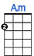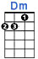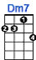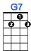
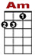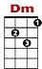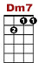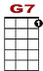
Just remember, darlin’, all the while, you be-long to me.

1
1 3 1 1 0
0 0
3 3 2 0 0 2

2nd VERSE:

See the marketplace in old Algiers, send me photographs and souve-nirs;

0 0
1 3 3 1 0 0 0 0 1 0 0
2 2 0 0 2

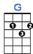
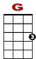
But remember when a dream appears, you be-long to me.

1 3 1 0 3 1
0 0
3 3 2 0 0 2

BRIDGE:
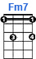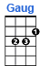
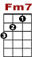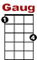
I'll be so a-lone without you; maybe you'll be lonesome, too, and blue.

0 3 3
1 0 3 1 1 0 3 0 1 4 3
0 2 2

3rd VERSE:

Fly the ocean in a silver plane, see the jungle when it's wet with rain;
Just remember till you're home a-gain, you belong to me.

BRIDGE:

I'll be so a-lone without you; maybe you'll be lonesome, too, and blue.

VERSE:

Fly the ocean in a silver plane, see the jungle when it's wet with rain;
Just remember till you're home a-gain, you belong to me.

