Yesterday by The Beatles

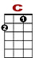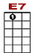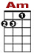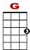

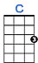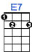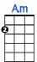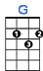
0 2 3 2 0 0
0 2 4
2 0 0

Yesterday, all my troubles seemed so far away.

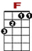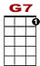

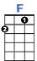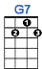

3 3 1 0 0
2 0 2 2

Now it looks as though they're here to stay.

0 0 0
0 0 2 0
0

Oh I be - lieve in yes-ter-day.

2nd VERSE:

Suddenly, I'm not half the man I used to be, there's a shadow hanging over me.
Oh yesterday won't set me free

CHORUS:

0 2 3 2 0 2 0 0
0 0 3 0

Why she had to go, I don't know, she wouldn't say.

0 2 3 2 0 2 0 2 3
0 0 3 3 1 0
2 2 0 0

I said some - thing wrong, now I long for yesterday. Yesterday …

3rd VERSE:

…, love was such an easy game to play, now I need a place to hide away.
Oh I believe in Yesterday

Repeat CHORUS

Repeat 3rd VERSE

