With A Little Help From My Friends by John Lennon & Paul McCartney

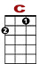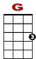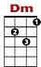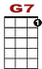
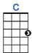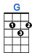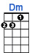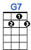

0 1 3 3 1 0 0 1 1 1 1 0 0
2 2 2 2 0 2

What would you do if I sang out of tune, would you stand up and walk out on me?

0 1 3 3 1 0 0 1 1 1 1 0
2 2 0 2 0 2 0

Lend me your ears and I’ll sing you a song and I’ll try not to sing out of key.
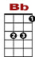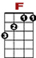
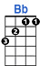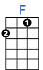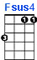

3 0 3 0
0 2 0 0 0 0 0 0 0 0 0 2 0 0 0 0 0 0 0 0

Oh I get by with a lit-tle help from my friends. Mm I get high with a lit-tle help from my friends.

3 0
0 2 2 0 0 0 0 0 0 0 0

Mm I’m gonna try with a lit-tle help from my friends.

2ND VERSE

What do I do when my love is away, does it worry you to be alone?
How do I feel by the end of the day, are you sad because you’re on your own?
No I get by with a little help from my friends. Mm I get high with a little help from my friends.
Mm I’m gonna try with a little help from my friends.

BRIDGE
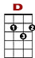
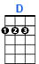

3 3 3 2 0
0 3 0 0 0
0 2 2 0

Do you need an-ny bod-dy? I need some bod-dy to love.

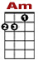
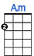

3 3 3 2 0
0 3 0 0 0
0 2 2 0

Could it be an-ny bod-dy? I want some-bod-dy to love.

3RD VERSE

Would you believe in a love at first sight? Yes, I’m certain it happens all the time.
What do you see when you turn out the light? I can’t tell you but I know it’s mine.
Oh I get by with a little help from my friends. Mm I get high with a little help from my friends.
Mm I’m gonna try with a little help from my friends.

