Will You Still Love Me Tomorrow by The Shirelles

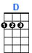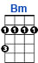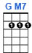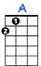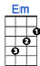
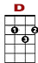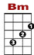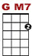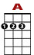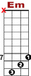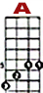

0 2 2 0 0 7 7 5
3 3 3 3 3 3

Tonight you're mine complete – ly. You give your love so sweet – ly.

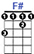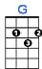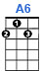
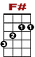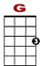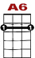
2 2 0 2 2 0 0 0
8 2 2 3 3 2 0 3 3
4

To-night the light of love is in your eyes. But will you love me tomor-row?

2nd VERSE: Is this a lasting treasure? Or just a moment's pleasure?
Can I believe the magic of your sighs? Will you still love me tomorrow?

BRIDGE:
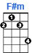
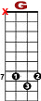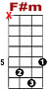

7 7 7 7 7 7 5 7 7 7 7 7 2
10 8

Tonight with words un-spo-ken, You said that I'm the on - ly one.

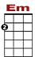

7 7 7 7 7 7 5 0 0 0
7 3 3 3 3

But will my heart be bro-ken, when the night meets the morning sun ?

3rd VERSE:

0 2 2 0 0 7 7 5
3 3 3 3 3 3

I'd like to know that your love , is love I can be sure of.

2 2 0 2 2 0 0 0
8 2 2 3 3 2 0 3 3
4

So tell me now and I won't ask a-gain. Will you still love me tomor-row?

