White Sandy Beach by Willie Dan

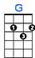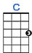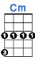
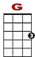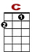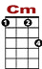
I saw you in my dream, we were walking hand in hand on a white sandy beach of Ha-wai-`i.

0 0 0 0 0
3 3 0 3 3 3 0 3 0 0 0
2 0 2 0 2 0 2

We were playing in the sun, we were having so much fun on a white sandy beach of Ha-wai-`i.

0 0 0 0 0
3 3 0 3 3 3 3 0 3 0 0 0
2 0 2 0 2 0 2

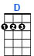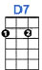
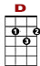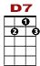
The sound of the ocean soothes my restless soul. The sound of the ocean rocks me all night long.

0 1 1 1 0 1 1 1 1 0 3
0 2 2 2 2 0 2 2 2 2 2

Those hot long summer days, lying there in the sun on a white sandy beach of Ha-wai-`i.

The sound of the ocean soothes my restless soul. The sound of the ocean rocks me all night long.

Last night in my dream, I saw your face again.

0 0 0 0
3 0 3 3 3 0 3

We were there, in the sun, on a white sandy beach of Ha-wai-`i

0 0 0 0 0
2 0 2 0 2 0 2 0 2 0 2

On a white sandy beach of Ha-wai-`i

0 0
2 0 2 0 2 0 2 0

