When I'm Sixty-Four by the Beatles

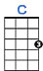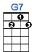
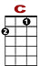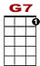

0
1 1 1 3 0 0 3 3 0 0 3 3 0
0 0 2 0 2 2 0
2 1 2 2
When I am old and losing my hair, many years from now, will you still be sending me a Valentine?
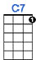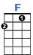
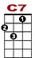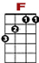

0 0 0
0 0 1 3 4 3 0 3 1
0 0 2 0 1 2
2 1 2 2
Birthday greetings, bottle of wine? If I'd been out to quarter to three, would you lock the door?

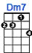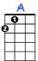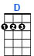
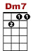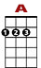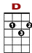

1 0 1 3 3 1 0 1
2 1 2 2 0 2 2

Will you still need me, will you still feed me, when I'm six - ty - four?

BRIDGE:
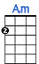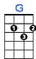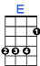
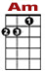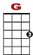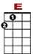

3 0
1 1 1 1 1 1 1 0 1
2 2 2 2 2 2 2 0 0 0 0 2 2
2
You'll be ol-der, too.

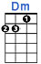
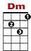

0 0
3 1 3 1 1
2 2 0 2

And if you say the word, I could stay with you.

2nd VERSE: I could be handy mending a fuse, when your lights have gone. You can knit a sweater by the fireside,
Sunday mornings go for a ride. Doing the garden, digging the weeds, who could ask for more?
Will you still need me, will you still feed me, when I'm six-ty-four?

BRIDGE:

1 1 1 1 1 1 1
2 2 2 2 2 2 2 0 0 0 0 2
2
Ev'ry summer we could rent a cottage in the Isle of Wight, if it's not too dear.

3 0 0 0
0 1 3 1 3 1 1
2 2 2 0 2

We shall scrimp and save. Grandchildren on your knee, Vera, Chuck and Dave.

3rd VERSE: Send me a post-card, drop me a line, Stating point of view. Indicate precisely what you mean to say.
Yours sincerely wasting away. Give me your answer fill in a form, mine forever more.
Will you still need me, will you still feed me, when I'm six-ty-four?

