What a Wonderful World by George David Weiss & George Douglas

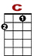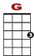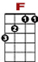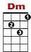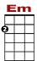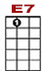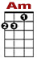

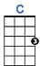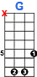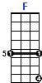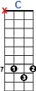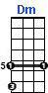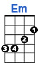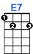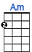

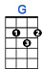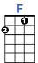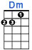
0 0 0
3 3 1 1 1 0
0 0 4 4 2 2 0
0 0
I see trees of green, red roses, too, I see them bloom for me and for you,

0 0
0 3 3
0 0 0 0 0 0 2 2 2 0 2 0 0
0 0
And I think to myself, "What a wonderful world." I see skies of blue, clouds of white

0 1 1 1
4 4 4 2 2 2 0 0 0 0 0 0 0 2 2 2 0 2 0

The bright blessed days and the dark sacred nights, and I think to myself, "What a wonderful world."

0 0 0 0 0 0 0 0 0 0
0 2 2 2 2 2 2 2 0 2 2 2 2 2 2 2

The colors of the rainbow, so pretty in the sky, are al-so on the faces of people passing by.

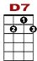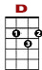

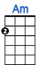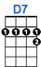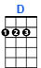
0 0 0 0 0 0 0 0
3 3 3 2 3
0 0 4 4 4 4 4 2

I see friends shakin' hands, sayin', "How do you do?" When they're really sayin', "I love you."

I hear babies cry, and watch them grow. They'll learn so much more than I will ever know,

0
0 0 0 0 0 0 2 2 2 0 2 0 0 0 0 2 2 2 0 2 0
0 0
And I think to myself, "What a wonderful world." Yes I think to myself, "What a wonderful world."

