Waltzing Matilda

1st VERSE:
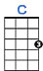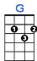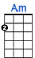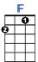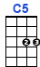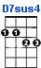

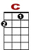 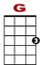 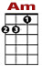 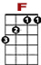 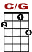 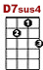
Once a jolly swagman sat beside the billabong, under the shade of a coulibah tree,

0 0 0 0 0 0 3 3 3 3 3 3 3
3 3 1 3 1 0 1 1
2 0

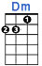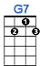

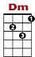 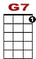
And he sang as he sat and waited by the billabong. You'll come a waltzing Ma til da with me.

0 0 0 0 0 3 1 0
1 3 3 3 1 3 0 1 1 3 3 3 1
0 2 0

CHORUS:

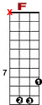 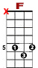
Waltzing Matilda, waltzing Ma-til-da. You'll come a waltz ing Matilda with me.

3 3 3 3 0 8 8 8 3 3 3 5 3 3 3 1 0
12 10 3

And he sang as he sat and waited by the billabong, you'll come a waltzing Ma til da with me.
0 0 0 0 0 3 1 0
1 3 3 3 1 3 0 1 1 3 3 3 1
0 2 0

2nd VERSE:

Down came a jumbuck to drink beside the billabong. Up jumped the swagman and seized him with glee.
And he sang as he tucked jumbuck in his tucker-bag. You'll come a waltzing Matilda with me.

CHORUS:
Waltzing Matilda, waltzing Matilda. You'll come a waltzing Matilda with me.
And he sang as he sat and waited by the billabong, you'll come a waltzing Matilda with me.

3rd VERSE:

Down came the stockman, riding on his thoroughbred; down came the troopers, one, two, three.
"Where's the jolly jumbuck you've got in your tucker-bag? You'll come a waltzing Matilda with me

CHORUS:

Waltzing Matilda, waltzing Matilda. You'll come a waltzing Matilda with me.
And he sang as he sat and waited by the billabong, you'll come a waltzing Matilda with me.

4th VERSE:

Up jumped the swagman and plunged into the billabong, "You'll never catch me alive," cried he.
And his ghost may be heard as you ride beside the billabong, You'll come a waltzing Matilda with me.

CHORUS:

Waltzing Matilda, waltzing Matilda. You'll come a waltzing Matilda with me.
And he sang as he sat and waited by the billabong, you'll come a waltzing Matilda with me.

