Lazy River by Hoagy Carmichael and Sidney Arodin

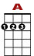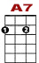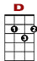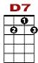
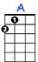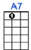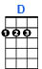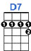

1 0
0 3 3 2 1 0 0 0
1 0 2 0 3 2
2 1 2 2 2 1 2
Up the lazy river by the old mill run, the lazy, lazy river in the noon-day sun.

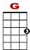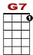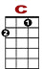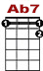
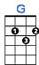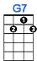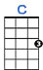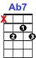

0
3 2 1 0 0
3 2 3 0 2 0 2 3 2 0
4 0 2 0 2
Layin' in the shade of a kind old tree, throw away your troubles, dream a dream with me.

1 0
0 3 3 2 1 0 0
1 0 2 0 2 2 1 0
2 1 2 2 2 1 2
Up the lazy river where the robin's song, awaits a bright new mornin' as we just roll along.

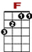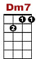
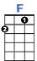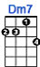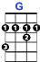

0 0 0 0
0 0 0 0 2
2 2 2 2 4 4 4
Blue skies up above, every one's in love, up the lazy river,

0 0 0
4 4 3 2 2 2 2 2 4 4 4

How happy we would be , up the lazy river with me. BACK TO BEGiNNING

2nd ENDING
0 0 0 0 0 2 2
0 0 0 0
0 0 0 0 2

Blue skies up above, every one's in love, up the lazy river,

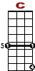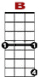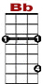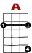
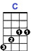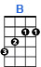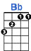

2 3 3 2 1 0 0 0 0 0 2 2 2 3

How happy we would be, up the lazy river with me.

