Under The Boardwalk by Kenny Young and Arthur Resnick

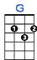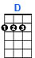
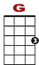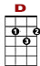

0 0 0 0 3 0 0 0
0 0 2 0 2
0
Oh when the sun beats down and burns the tar upon the roof,

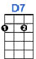
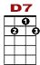

0 1 1 1 1 1 3 3 3 1 1 1 0 0
2

And your shoes get so hot you wish your tired feet were fire-proof.

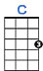
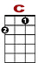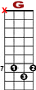

3 3 3 0 3 3 5 7
1 10 8 3 1 0

Under the boardwalk, down by the sea,

0 0 1 0 0

0 2 2 2 2 2 0

On a blanket with my baby is where I’ll be.

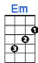

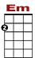
0 0 2 0 0
3 3 3 3 3

0 0 1 2 2 2 2 1 0 0

Under the boardwalk (out of the sun), Under the boardwalk (we’ll be having some fun)

0 0 0 0 2 0 0
3 3 3 3

0 0 1 2 2 2 2 1 0 0

Under the boardwalk (people walking above), Under the boardwalk (we’ll be making love)

0 0 1 2 2 2 2
Under the boardwalk, boardwalk.

2nd VERSE:

From the park you hear the happy sound of a carousel.
Mm-mm, you can almost taste the hot dogs and French fries they sell.
Under the boardwalk, down by the sea, on a blanket with my baby is where I'll be.

REPRISE:

Under the boardwalk, down by the sea, on a blanket with my baby is where I'll be.

