Try A Little Tenderness

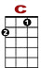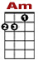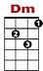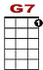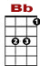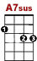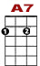
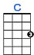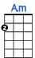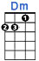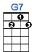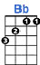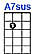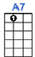

2 2 3 3 3 1 1 1 0
3 0 0 1 3 0
2 0 0 0 2

She may be weary, and young girls do get weary, wearing that same old shabby dress.

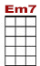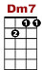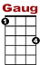
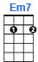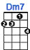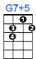

0 1 3 1 0 0 1 3 3 0
2 2 2

But when she gets wea-ry, try a lit-tle tenderness.

2nd VERSE: You know she’s waiting, anticipating the things she may never, never, never possess.
C C7
But while she’s there waiting without them, try a little tender-ness.

BRIDGE:
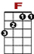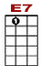
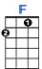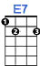

0 1 1 3 1 0 0 0 0 0 0
2 1

It’s not just sentimental; she has her grief and care.

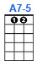

0
0 0 1 1 3 1 1 0 0 0 3 1 0
2

And a word that’s soft and gen - tle makes it ea-si-er to bear.

3rd VERSE:

2 2 3 3 3 1 1 1
3 0 0 1 3 0
2 0 0 0 0 2 2

You won’t regret it, no, no; young girls they don’t for-get it. Love is their whole happiness.

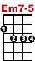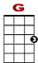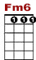
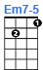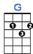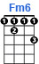

1 1 0 0
0 1 3 1 0 0 1 3 0 1 3 1 0
2 2 2

But it’s all so eas-y, all you got to do is try. Try a lit-tle ten – der - ness.

