Time After Time by Cyndi Lauper, Eva Marie Cassidy and Robert Hyman

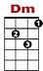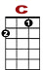
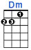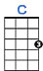

0 0 0 0 0
2 0 0 2 0 0 0 2 0 0 2 2 0 2 0 0 2 0 0 2

Lyin’ in my bed I hear the clock tick and think of you. Caught up in cir - cles con - fu - sion is nothing new.

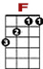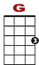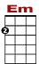
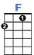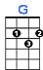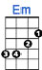

2
0 0 0 0 0 2 0 0 0
4 4 4 0 4 4 4 4
Flash - backs, warm nights. Al-most left be-hind. Suit - case of mem-o - ries, time af - ter …

0 2 0 0 0 0 0
2 0 2 2 0 0 0 0 2 2 0 2 0 0 2 0 2

Sometimes you picture me, I'm walk - ing too far a-head. You're calling to me I can't hear what you've said.

BRIDGE:

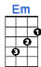

0 0 2 0 0 0 0 0
4 4 0 4 0 0 2
Then you say go slow, I fall be-hind. The sec-ond hand un-winds.

CHORUS:
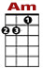
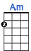
0
3 3 3 3 3 3 0 0 0 0
2 2 2 2

If you're lost you can look and you will find me. Time af - ter time.

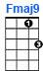
0
0 3 3 0 3 3 0 3 3 0
0 0 0 0

If you fall I will catch you I'll be waiting. Time af-ter time. REPEAT CHORUS

2nd VERSE: Af - ter my picture fades and darkness has turned to grey.
Watching through win-dows, you're wondering if I'm OK.

BRIDGE: Secrets sto-len from deep inside. The drum beats out of time.

CHORUS

BRIDGE: You said go slow, I fall behind. The second hand unwinds.

CHORUS 2X

