Three Little Birds by Bob Marley

CHORUS:

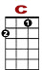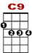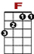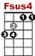

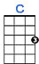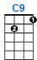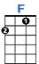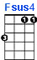

0 0 0 0 0 0 0 0 0 1 0
3 3 0 3 0 3 3

Dont worry bout a thing, cause every little thing is gonna be all right.

0 0 0 0 0 0 0 0 1 0
3 3 3 3 0 3 0 3 3

Singing don't worry bout a thing, cause every little thing gonna be all right.

VERSE:


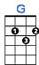

0 0 0 1 0 0 0 0 0
0 2 0 2 2 2 2 0 0 2 0

Rise up this mornin, smiled with the ris – in sun. Three little birds pitch by my doorstep

0 0 0 1 0 0 0
0 2 0 2 2 2 2 0 0 0 0 2 0 2 0

Singin sweet songs of melodies pure and true. Sayin, this is my message to you-ou-ou.

Repeat CHORUS, Repeat VERSE, Repeat CHORUS, Repeat CHORUS

