The Glory of Love by Billy Hill

1st VERSE:
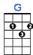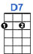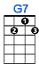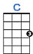
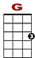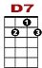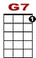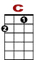

0 1 3 3 3 3 3 3 1
0 2 2 0
0 2 0 2 0 2 0
You’ve got to give a lit-tle, take a lit-tle, and let your poor heart break a lit-tle.

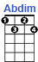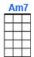
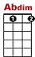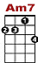

0 0 0
2 0 2 2 2 0 0
4
That’s the stor-ry of, that’s the glo-ry of love.

2nd VERSE:

0 1 3 3 3 3 3 3 1
0 2 2 0
0 2 0 2 0 2 0
You’ve got to laugh a lit-tle, cry a lit-tle, before the clouds roll by a lit-tle.

0 0 0
2 0 2 2 2 0 0
4
That’s the sto-ry of, that’s the glor-ry of love.

INTERLUDE:

0 0
1 1 3 3 1 1 3 3 3 1 1 0
0 0

As long as there’s the two of us, we’ve got the world and all its charms.

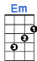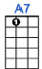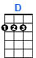
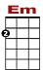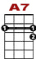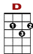

0 3 3 2 3 0
1 1 3 3 0 3
0 0

And when the world is through with us, we’ve got each ot-her’s arms.

3rd VERSE:

You’ve got to win a little, lose a little, and always have the blues a little.

That’s the story of, that’s the glory of love. REPEAT WITHOUT C7

