Tears in Heaven by Eric Clapton

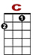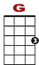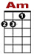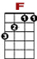

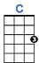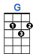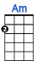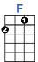

0 3 3 0 1 1 0 0
0 2 0 2

Would you know my name, if I saw you in heaven?

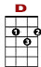

0 3 3 0 1 1 0 0
0 2 0 2

Would it be the same, if I saw you in heaven?

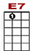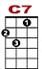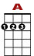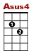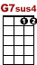

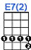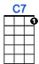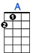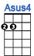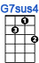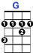
0 1 0 0
0 0 2 0 2 2 0 2 2 0
4 3 3 2 4
I must be strong, and carry on, cause I know I don't belong here in heaven.

2nd VERSE: Would you hold my hand, if I saw you in heaven?
Would you help me stand, if I saw you in heaven?
I'll find my way through night and day, 'cause I know I just can't stay here in heaven.

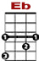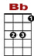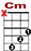

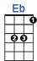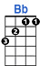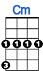

3 3 1 1 1 2
2 3
5 5
Time can bring you down, time can bend your knees.

3 3 1 1 1 1 1 3
2 3 3 2
5
Time can break your heart, have you beggin' please beggin' please.

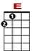
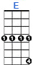

0 1 0 0
0 0 2 0 2 2 0 2 2 0
4 3 3 2 4
Beyond the door, there's peace for sure and I know there'll be no more tears in heaven.

3rd VERSE: Would you know my name, if I saw you in heaven?
Would it be the same, if I saw you in heaven?
I must be strong, and carry on, ‘cause I know I don't belong here in heaven.

