Somewhere West Side Story

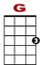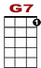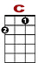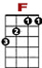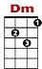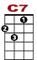
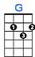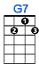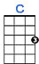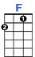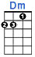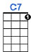

0
1 0 3 1 0
0 0
0 2 2
There's a place for us, somewhere a place for us,

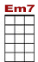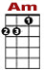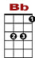
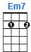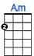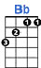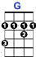

0 0
0 1 3 3 0 1
2 0 2 0
4
Peace and qui-et and o - pen air wait for us somewhere.

0
1 0 3 1 0
0 0
0 2 2
There's a time for us someday a time for us,

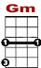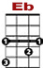
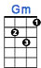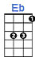

0 0 1
0 1 3 3 0 1 3
2 0 2 3

Time to-ge-ther with time to spare, time to learn, time to care,

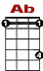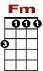
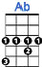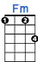
NO
CRD

NO
CRD

NO
CRD

1 3 1 3 1 3

Some - how, some - day, some - where

Repeat first five lines instrumental only, then finish below.

0
1 0 3 1 0
0 0
0 2 2
There's a place for us, a time and place for us

1 0 1
0 3 0 1 0 1 3
0 2 0 2 3
4
Hold my hand and we're half-way there, hold my hand and I'll take you there

NO
CRD

NO
CRD

NO
CRD

1 3 1 3 1 3

Some - how, some - day, some - where

