Somewhere Over the Rainbow by E.V. Harburg and Harold Arlen

1st VERSE:
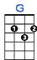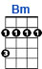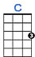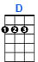

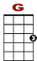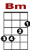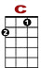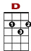
Somewhere over the rainbow way up high, there's a land that I heard of once in a lull a – by.

3 2 0 2 3 0
3 3 1 0 0 1 0
0 0 0 2 2 0 2 0
2 4

2nd VERSE:

Somewhere over the rainbow skies are blue. And the dreams that you dare to dream really do come true.

CHORUS:
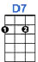

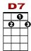
Someday I'll wish upon a star and wake up where the clouds are far be-hind me

0 0
3 0 3 0 3 0 3 0 3 1 3 1 3 1 3 1 3

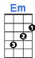

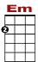
Where troubles melt like lemon drops a way above the chimney tops, that's where you will find me.
0 0 0 0 2
3 0 3 0 3 0 3 0 3 1 3 1 3 1 3 1 3

3rd VERSE:

Somewhere over the rainbow bluebirds fly. Birds fly over the rainbow. Why then, oh why can't I?

ENDING:
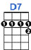

If hap-py lit-tle bluebirds fly beyond the rainbow, why, oh why can't I?

0 2 3
3 0 3 0 3 0 3 0 3 1 3 1 3 1 3

