Somewhere Over the Rainbow by E.V. Harburg and Harold Arlen

1st VERSE:
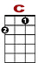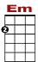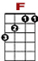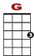

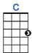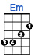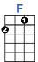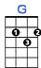

3 2 0 2 3 0
3 3 1 0 0 1 0
0 0 0 2 2 0 2 0
2 4
Somewhere over the rainbow way up high, there's a land that I heard of once in a lull a – by.

2nd VERSE:

Somewhere over the rainbow skies are blue. And the dreams that you dare to dream really do come true.

CHORUS:
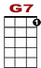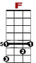

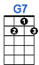

0 0
3 0 3 0 3 0 3 0 3 1 3 1 3 1 3 1 3

Someday I'll wish upon a star and wake up where the clouds are far be-hind me

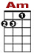

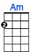
0 0 0 0 2
3 0 3 0 3 0 3 0 3 1 3 1 3 1 3 1 3

Where troubles melt like lemon drops a way above the chimney tops, that's where you will find me.

3rd VERSE:

Somewhere over the rainbow bluebirds fly. Birds fly over the rainbow. Why then, oh why can't I?

ENDING:

0 2 3
3 0 3 0 3 0 3 0 3 1 3 1 3 1 3

If hap-py lit-tle bluebirds fly beyond the rainbow, why, oh why can't I?

