Someday Soon (High Melody) written by Ian Tyson

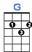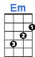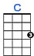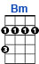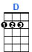
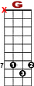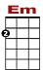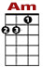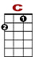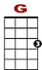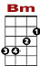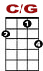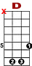

7 0 0 2 2 2 2 2 0 2 3 5
8 10 10 8 0 3
2 0 0 2

There's a young man that I know, just turned twen - ty - one, comes from down in southern Col-o - ra - do,

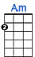
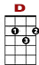

7 0 0 0 0 0
8 10 10 8 0 3 3 0
2 0 0 2 2 2 2 0

Just out of the ser-vice and look - ing for his fun. Some-day soon, go-ing with him someday soon.
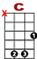

7 0 0 0 3 2 2 2 2 2 0 2 3 5
8 8 10 10 8 0 3
2 0 0 2

My par-ents can-not stand him 'cause he works the ro-de-os. They say, "he's not your kind, he'll leave you cry - ing"

7 0 0 0 0 0
8 8 10 10 8 0 0 0 3 3 0
2 0 0 2 2 2 2 0

But if he asks, I'll fol-low him down the tough - est row to hoe. Some-day soon, going with him someday soon.

BRIDGE:
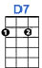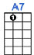
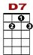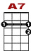

0 1 1 1 1 1 1 0 0 1 1 1 0 3
0 2 2 2 2 2 2 2 2 2 2 2 2 2

And when he vis-its me, my pa ain't got one good word to say. Got a hunch he was as wild back in the ear-ly days

2nd VERSE:

So, blow you old blue nor-ther, blow him back to me. He's like-ly driving back from Cal-li-for-nia.
He loves his damned old ro-de-os as much as he loves me. Someday soon, go-ing with him someday soon,
Someday soon, go-ing with him someday soon.

