Save The Last Dance For Me by The Drifters

VERSE:
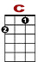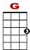
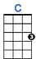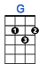

0 0 0 0 0 0 0 0 0 0 0 1 1 0 0
0 2 2 2

You can dance every dance with the guy who gives you the eye, let him hold you tight.

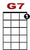
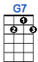

0 1 1 1 1 1 1 1 1 1 1 3 3 1 1 0 0
2

You can smile every smile for the man who held your hand 'neath the pale moonlight.

CHORUS:
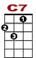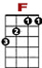
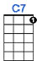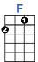

0 0 0 0 2 3 3 2 0 0
0 1 3 3 3 1 0

But don't for-get who's taking you home and in whose arms you're gon-na be.

3 3 0 1 0
2 2 2 0

So darling, save the last dance for me.

VERSE: Oh I know that the music is fine like sparkling wine go and have your fun.
Laugh and sing, but while we're apart, don't give your heart to anyone.

CHORUS

BRIDGE:

3 3 3 1 0 0
2 2
0 0 2 2 0 0 4 0

Baby don't you know I love you so? Can't you feel it when we touch?

3 3 3 1 0
2 2 0
0 0 2 2 0 0 4 0

I will never, never let you go. Cause I love you oh so much.

VERSE: You can dance, go and carry on till the night is gone and it's time to go.
If he asks, if you're all alone can he take you home, you must tell him no.

CHORUS – REPEAT

