On a Slow Boat to China by Frank Loesser

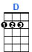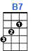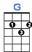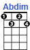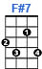

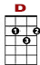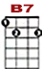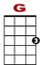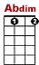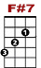

2 0 3 2 0 2 0
3 0 0 0 0 3 0 3 2 0
2

I'd love to get you, on a slow boat to Chi - na, all to my - self a - lone.

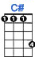

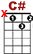
3 2
0 3 0 0 2 3 3 2 0

Get you to keep you in my arms ev – er - more,

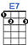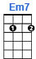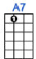
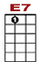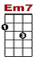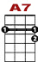
0 0
3 3 0 3 3 3 0 3 2 0
2

Leave all your lov - ers, weeping on the far – a - way shore.

2 0 3 1 0 2 0
3 0 0 0 0 0 3 0 3 2 0
2

Out on the bri - ny, with the moon big and shiny, mel - ting your heart of stone.

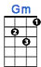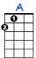

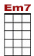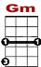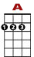

2 0 0 0 2 0
0 0 3 3 3 0 3 0 4 3
3 2

I'd love to get you, on a slow boat to Chi - na, all to my - self a - lone.

