Norwegian Wood by The Beatles

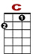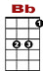
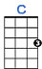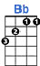

0
3 3 1 0 1 0 1
2 0
3 3 0
I once had a girl, or should I say, she once had me

0
3 3 1 0 1 0 1
2 0
3 3 0
She showed me her room, isn't it good, Norwegian wood
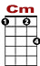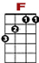
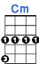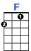

3 3 3 3 3 1
5 3 3 3 3 3 5 3

She asked me to stay and she told me to sit any – where

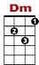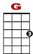
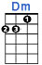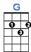

3 3 3 1
0 0 5 3 3 3 3 3 3 5
So I looked around and I noticed there wasn't a chair.

I sat on a rug, biding my time, drinking her wine. We talked until two, and then she said, it's time for bed.

She told me she worked in the morning and started to laugh.

I told her I didn't and crawled off to sleep in the bath.

And when I awoke, I was alone, this bird had flown. So, I lit a fire, isn't it good, Norwegian wood.

