While My Guitar Gently Weeps by George Harrison and The Beatles

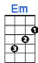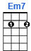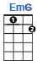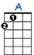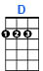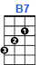
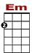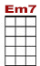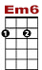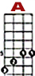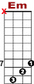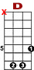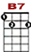

0 2 3 0 2 3 0 2 3 5 7 5
0 8 8 7 5
9 7

I look at you all, see the love there that's sleeping, while my gui-tar gently weeps.

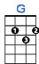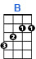
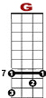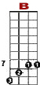

0 2 3 0 2 3 0 2 3 5 7 5 5 5 7
0 8 8
9

I look at the floor, and I see it needs sweeping, still my gui-tar gently weeps.

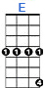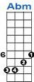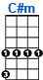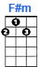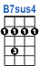
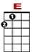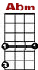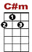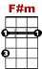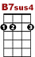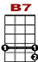

1 0 1 4 1 0 1 0
4 4 1
6 4 3 4 4
I don't know why-y, nobody told you, how to unfold your love.

REFRAIN:

4 0
1 0 1 4 1 0 1 4 1
6 4 3 4 4
I don't know how-ow, someone controlled you, they bought and so-ld you.

0 2 3 0 2 3 0 2 3 5 7 5 0
0 8 8 7
9 7

I look at the world and I notice it's turning, while my gui-tar gently weeps.

0 2 3 0 2 3 0 2 3 5 7 5 5 5 7
0 8 8
9

With every mistake we must surely be learning, still my gui-tar gently weeps.

2nd VERSE: I don't know how you were diverted, you were per-verted too.
I don't know how you were inverted, no one alerted you.

REFRAIN: I look at you all, see the love there that's sleeping, while my guitar gently weeps.
I look at you all, see the love there that's sleeping, still my guitar gently weeps.

