Moonlight Bay by Percy Wenrich and Edward Madden

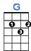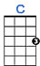

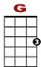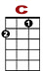

0 0 1 0
0 2 2
0 0 2
We were sailing a-long, on Moonlight Bay

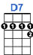

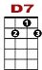

0 0 0 1 0
3 3 2 2 1 2
0
We could hear the voices ring - ing, they seemed to say,

0 0 1 0
0 2 2
0 0 2
"You have stolen my heart, now don't go 'way!"

1 0 0
2 2 2 2 0
0 0 0
As we sang love's old sweet song on Moonlight Bay.

