Michelle by The Beatles

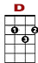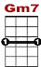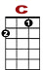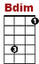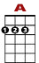
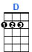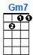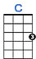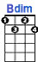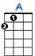

0 0 1 0
1 0 0 1 3 1 0 1 0
3 2 2

Michelle, ma belle, these are words that go together well, my Mi-chelle

0 0 1 0
1 0 0 1 3 1 0 0 1 0
3 2 2

Michelle, ma belle, sont les mots qui vont tres bien en-semble, tres bien en-semble

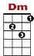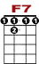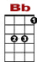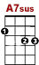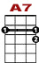
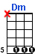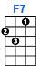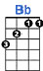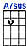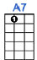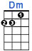

0 5 5 7 5 0 0 1 0 0 0 0 5 0
8 5 8 5 3 1 1

I love you, I love you, I love you. That's all I want to say, un-til I find a way

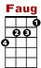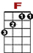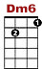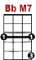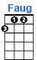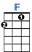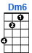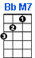

0 0 0 0 0 0 0 0 0
1 3 3 1 0

I will say the on-ly words I know that you'll understand

Michelle, ma belle, sont les mots qui vont tres bien en-semble, tres bien en-semble

I need to, I need to, I need to, I need to make you see, oh, what you mean to me

Until I do I'm hoping you will know what I mean

I want you, I want you, I want you, I think you know by now. I'll get to you somehow
Until I do I'm telling you so you'll understand

Michelle, ma belle, sont les mots qui vont tres bien en-semble, tres bien en-semble

I will say the only words I know that you'll understand, my Michelle

