Makin' Whoopee by Gus Kahn & Walter Donaldson

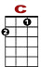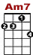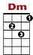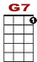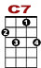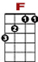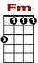
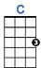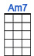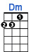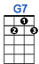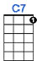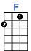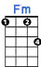

0 1 3 3 3 3 0

0 2 0 0 2 0 0 2 0
Another bride, another June, another sunny honey-moon.

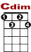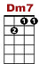
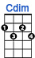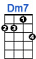

1 3 1 0 0 0
2 2 0 2 0 0
0 2 0
Another season, another reason for makin' whoopee.

VERSE 2:

0 1 3 3 3 3 3 0

0 2 0 0 2 0 0 2 0
You get some shoes, a lit-tle rice, The groom's so nervous he answers twice.

1 3 1 0 0 0
2 2 0 2 0 0
0 2 0
It's really thrillin' that he's so willin' for makin' whoopee.

BRIDGE 1:

1 1 0 0
3 3 3 1 1 1 1 1 0

Picture a lit-tle love nest. Down where the ro-ses cling.

1 1 0 0
3 3 3 1 1 1 1 1 1
2

Picture that same sweet love nest. And see what a year will bring.

VERSE 3:

He's doin' dishes and baby clothes. He's so ambitious, he even sews.
Just don't forget, folks, that's what you get, folks, for makin' whoopee.

VERSE 4:

Another year or maybe less, what's this I hear? Well, can't you guess?
She feels neglected and he's suspected of makin' whoopee.

VERSE 5:

She sits a-lone 'most every night, he doesn't phone her, he doesn't write.
He says he's "busy" but she says "is he?" He's makin' whoopee.

BRIDGE 2:

He doesn't make much money, only a five-thousand per.
Some judge who thinks he's funny, told him he got to pay six to her.

VERSE 6:

He says: "Now judge, suppose I fail." The judge says, "Budge right into jail!
You'd better keep her. I think it's cheaper. Than makin' whoopee.

