Let’s Do It, Let’s Fall In Love by Cole Porter

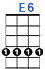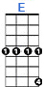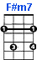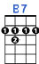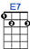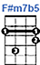
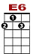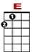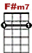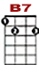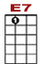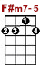

0 1 2 1 0
2 1 0 2 1 0 2 1 2 4 2 1 0 2 1 0
1

Birds do it, bees do it, ev-en ed-u-ca-ted fleas do it, let's do it, let's fall in love.
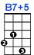
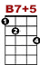

0 1 2 1 0 0
2 2 2 2 1 0 2 1 0 2 1 2 4 2 1 0 2 1 0

In Spain the best upper sets do it, Li-thu-an-i-ans and Letts do it, let's do it, let's fall in love.
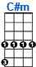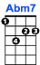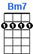
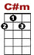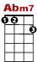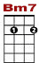

0 0 0 0 0
4 2 4 2 4 3 4 2 0 3

The Dutch in old Am-ster-dam do it, not to mention the Finns.
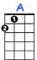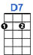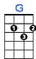
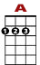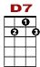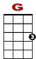

2 1 0 1 0 0 0 0 2 2 2 2 1 0 2 1 0
2 3 2 0

Folks in Si-am do it, think of Si-a-mese twins. Some Ar-gen-tines without means do it,

0 0 1 2 1 0 0
2 1 2 4 4 2 1 0 2 1 0

People say in Boston e-ven beans do it Let's do it, let's fall in love.

The nightingales, in the dark do it, larks crazy for a lark do it, let’s do it, let’s fall in love.
Canaries caged in the house do it, when they’re out of season, grouse do it, let’s do it, let’s fall in love.
The most sedate barnyard fowls do it, when a chanticleer cries,
High-browed old owls do it, they’re supposed to be wise.
Penguins in flocks, on the rocks do it, even little cuckoos in their clocks do it, let’s do it, let’s fall in love.

Romantic sponges, they say, do it, oysters down in Oyster Bay do it, let’s do it, let’s fall in love.
Cold Cape Cod clams ‘gainst their wish do it, even lazy jellyfish do it, let’s do i , let’s fall in love.
Electric eels, I might add, do it, though it shocks them I know,
Why ask if shad do it, waiter, bring me some shad roe.
In shallow shoals, English soles do it, goldfish in the privacy of bowls, do it, let’s do it, let’s fall in love.

The dragonflies, in the reeds do it, sentimental centipedes do it, let’s do it , let’s fall in love.
Mosquitoes, heaven forbid do it, so does every katydid do it, let’s do it , let’s fall in love.
The most refined ladybugs do it, when a gentleman calls.
Moths in your rugs do it, what’s the use of moth balls?
Locusts in trees do it, bees do it, even overeducated fleas do it, let’s do it, let’s fall in love.

The chimpanzees, in the zoos do it, some courageous kangaroos do it, let’s do it, let’s fall in love.
I’m sure giraffes, on the sly do it, heavy hippopotami do it, let’s do it, let’s fall in love.
Old sloths who hang down from twigs do it, though the effort is great.
Sweet guinea pigs do it, buy a couple and wait.

0 0 1 2 1 0 0
2 2 2 2 1 0 2 1 0 2 1 2 4 4 2 1 0 2 1 0

The world ad-mits bears in pits do it, even Pekinese’s in the Ritz do it, let’s do it, let’s fall in love.

