Let Me Call You Sweetheart in G by Beth Whitson & Leo Friedman

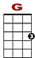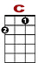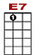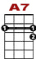
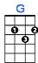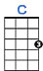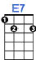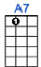

0 2 0
0 3 0 0
2 2 2 2

Let me call you sweetheart, I’m in love with you.

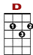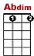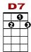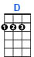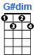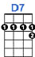
0
2 0 2 3 2 0 2
2 2 2

Let me hear you whisper that you love me too.

0 2 0
0 3 0 0
2 2 2 2

Keep the love light glowing in your eyes so true.

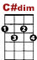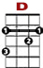
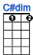

0 2 3 2
3 2 3 0 2 3
2

Let me call you sweetheart, I’m in love with you.

