Let Me Call You Sweetheart in C by Beth Whitson & Leo Friedman

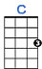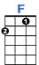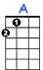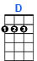
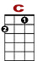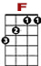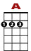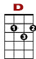
0
1 3 3
0 2 0 0 0 2 2

Let me call you sweetheart, I’m in love with you.

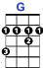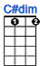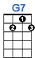
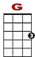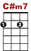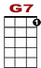

0 0 1 3 0 0
3 2 0 0 0

Let me hear you whisper that you love me too.

0
1 3 3
0 2 0 0 0 2 2

Keep the love light glowing in your eyes so true.

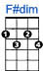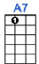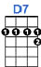
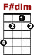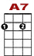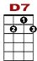

0 1 0
1 0 1 3 0 1
0 2

Let me call you sweetheart, I’m in love with you.

