Let Me Call You Sweetheart in C by Beth Whitson & Leo Friedman

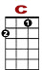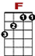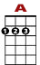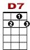
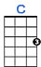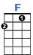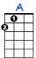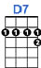

0
0 2 2
0 2 0 0 0 2 2
Let me call you sweetheart, I’m in love with you.

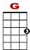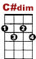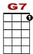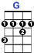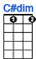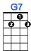

0 2
4 3 4 4 2 4 0 0 0
Let me hear you whisper that you love me too.

0
0 2 2
0 2 0 0 0 2 2
Keep the love light glowing in your eyes so true.

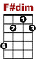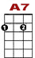
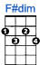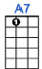

0 1 0
0 3 3 0
4 0 2 4
Let me call you sweetheart, I’m in love with you.

