Kodachrome by Paul Simon

1st VERSE:
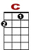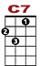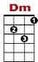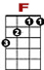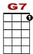

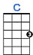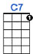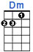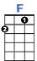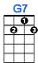

0 3 0 3 0 3 0 1 1 1 1 1 0 0
0 0 3 3 2 0 2 0

When I think back on all the crap I learned in high school, it's a wonder I can think at all

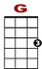

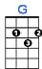

0 3 0 3 0 3 0 1 1 1 1 0
0 0 3 3 2 0 0 2 2 0 0

And though my lack of ed - u – ca - tion hasn't hurt me none, I can read the writing on the wall.

CHORUS:

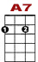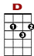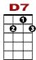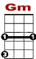

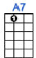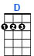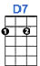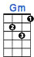

0 0 0 0 0 0 0 1 0 0
0 3 3 0 0 0 1 0 3

Ko – da - chro - o - me, you give us those nice bright col-ors, you give us the greens of

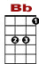

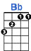

0 0 0 0 1 0
1 0 1 3 1 0 3 1 0 3 0
2 2 0 2

Summers. Makes you think all the world's a sunny day, oh yeah! I got a Nikon camera.

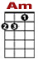

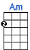

0 0
0 0 1 3 0 3 1 0 1 3 1 0 3 1
2 2 0

I love to take a photograph. So, Mama, don't take my Kodachrome a-way

2nd VERSE:

If you took all the girls I knew when I was single and brought them all together for one night
I know they'd never match my sweet imagination and everything looks worse in black and white

CHORUS:

Kodachrome, you give us those nice bright colors, you give us the greens of summers.
Makes you think all the world's a sunny day, oh yeah! I got a Nikon camera.
I love to take a photograph. So, Mama, don't take my Kodachrome a-way

