Just Give Me A Reason by P!nk

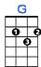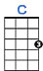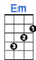
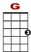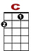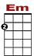

0 0
0 0 0 0 0 1 1 1 1 0 3 0 0
0 2 0 0

Right from the start you were a thief you stole my heart and I your willing victim.

0 0
0 0 0 0 0 0 0 1 1 1 0 0 3 0 0
0 2 0 0 0

I let you see the parts of me that weren't all that pretty and with every touch you fixed them.
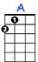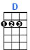
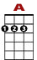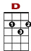

3 3 3 2 0 5 2 3 3 3 3 2 0 5 2 3
3 3
0

Now you've been talking in your sleep, oh oh, things you never say to me, oh oh,
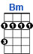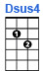
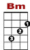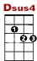

3 3 3 2 0 5 2 3 2 0
3 3

Tell me that you've had e–nough of our love, our love.

CHORUS:
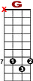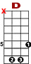

7 7 7 7 5 5 5 5 3 3 3 3 3 2 0 2
8 8 7 7
7 7 7

Just give me a reason just a lit-tle bit's enough, just a second we're not broken just bent.

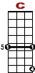
8 7 5 5 7 7 7 5 5 5 5 3
3 3 3 8 8 8 7 7
7 7

And we can learn to love a-gain. It's in the stars. It's been written in the scars on our hearts.

3 3 3 2 0 2 8 7 5 5 3
3 3 3

We're not broken just bent. And we can learn to love a-gain.

2nd VERSE: Im sorry I don't understand where all of this is coming from I thought that we were fine.
Your head is running wild again, my dear we still have everything and it’s all in your mind.
You've been having real bad dreams, oh oh, you used to lie so close to me, oh oh,
There's nothing more than empty sheets between our love, our love, oh our love.

CHORUS: Just give me a reason just a little bit's enough, just a second we're not broken just bent
And we can learn to love again.
It's in the stars, It's been written in the scars on our hearts, we're not broken just bent
And we can learn to love again.

