I’m Confessin’ (That I Love You) by Doc Daugherty and Ellis Reynolds

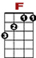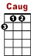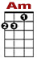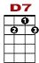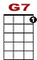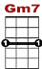
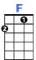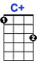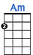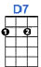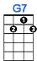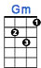

0
0 1 0 0 0 0 1 0 0 0 1 3 1 3 3
0 2 0 0 2 0 2

Im confessin’ that I love you. Tell me do you love me too? I’m confessin’ that I need you,

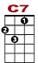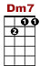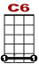
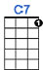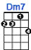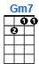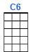

0 0
3 1 0 1 1 1 0 1 0 0 0
2 2 0 2 0 0 2

honest I do. Need you every moment. In your eyes I read such strange things, but your

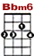
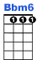
0
0 1 0 0 0 1 3 1 3 3 3 1 0 1
0 2

lips de - ny they’re true. Will your answer really change things making me blue.

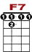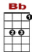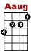
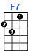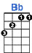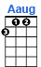

0 1 0 0 1 0 0 1 0
1 3 1 3 3 1 3 1 3 1 3

I’m afraid some day you’ll leave me, sayin’,”Can’t we still be friends?” If you go you know

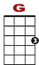
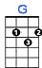

0 1
1 3 3 1 3 1 0 1 0 0 0
2 0 0 2 0

you’ll grieve me, all in life on you de - pends. Am I guessin’ that you love me,

0
0 1 0 0 0 1 3 1 3 3 3 1 0 1
0 2 0 2

dreaming dreams of you in vain. I’m confessin’ that I love you o - ver a - gain.

