Hotel California by the Eagles

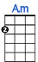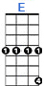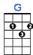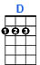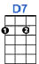
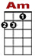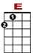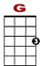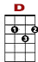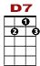

0 0 0 0 0 0 0
3 1 3 3 3 3 3 3 3 3 3 0 3 3 3 1 0 1

On a dark desert highway, cool wind in my hair, warm smell of colitis rising up through the air.

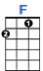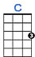
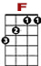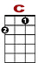
0 0 0
1 1 1 1 1 3 1 3 3 1 1

Up ahead in the distance, I saw a shimmering light.

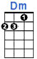
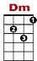
0 0 0 0 0 0 0
3 3 3 3 3 3 3 3 3
2

My head grew heavy and my sight grew dim, I had to stop for the night.

Verse 2: There she stood in the doorway. I heard the mission bell.
And I was thinking to myself this could be heaven or this could be hell.
Then she lit up a candle, and she showed me the way.
There were voices down the corridor; I thought I heard them say …

Chorus:

1 1 1 1 1 1 3 1 1 0 0 0 0 1 1 1 0 0
3 3

Welcome to the Hotel Califor-nia. Such a lovely place, such a lovely face.

1 1 1 1 1 1 1 1 3 1 1 0 0 0 0 0 0 0 1 1 1 0 0
3 3 3 3

Plenty of room at the Hotel Califor-nia. Any time of year (any time of year) you can find it here.

Verse 3: Her mind is Tiffany twisted, She got a Mercedes Benz.
She got a lot of pretty pretty pretty boys that she calls friends.
How they danced in the court yard sweet summer sweat.
Some dance to remember. Some dance to forget. Chorus

Verse 4: So I called up the captain; Please bring me my wine (he said).
We haven't had that spirit here since 1969.
And still those voice are calling from far away.
Wake you up in the middle of the night, just to hear them say … Chorus

Verse 5: Mirrors on the ceiling, the pink champagne on ice (an she said),
We are all just prisoners here, of our own device.
And in the master's chambers, they gathered for the feast.
They stab it with their steely knives but they just can't kill the beast. Chorus

Verse 6: Last thing I remember, I was running for the door
I had find the passage back to the place I was before
"Relax" said the night man; we are programmed to receive
You can check out anytime you like but you can never leave ... Chorus

