Hey Jude by the Beatles

1st VERSE:
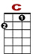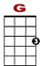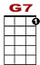
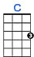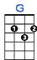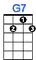

0 3 3 2 0
3 0 0 3 0 1 3 3 1 0
2 2

Hey Jude, don't make it bad. Take a sad song and make it bet t e r.
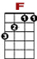
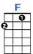

0 0 0 5 3 2 3 0
3 3 0 3 3 1
0 2 2 0
4
Remember to let her into your heart, then you can start to make it bet-ter

2nd VERSE: Hey Jude, don’t be afraid. You were made to go out and get her.
The minute you let her under your skin, then you begin to make it better.

REFRAIN:
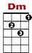
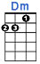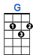

3 0 0 0 3 0 3 3 0 0
3 3 1 1 3 1 3 3 1 0
0 2 0

And an-ny time you feel the pain, hey Jude, re-frain, don't car-ry the world upon your shoul-der.

3 0 0 0 3 0 0 3 0 0
3 3 3 1 1 3 1 3 3 1 0
0 2 0

For don't you know that it's just a fool who plays it cool by making his world a little col - der.

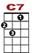
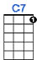

0 2
0 1 3 3 3

Na, na na, na na, na, na.

3rd VERSE: Hey Jude don't let me down. You have found her, now go and get her.
The minute you let her into your heart, then you can start to make it better.

REFRAIN: So let it out and let it in, hey Jude, begin. You're looking for someone to get closer.
But don't you know that it's just you, hey Jude, you'll do, the movement you need is on your shoulder.
Na, na na, na na, na, na

4th VERSE: Hey Jude, don't make it bad. Take a sad song and make it better
Remember to let her into your heart, then you can start to make it better.

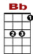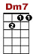
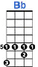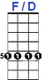

5 5 5 5 0 5 5 5 5 0
0 3 8 8 8 8 3 0 3 8 8 8 8 3
0 0

Na na, na na-na-na-na na-na-na-na, hey Jude. Na na, na na-na-na-na na-na-na-na, hey Jude.

