Hello In There by John Prine

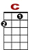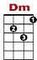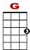
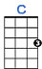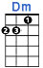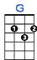

3 3 3 3 2 0 0 0 3 3 3 2 0 0
3 3 3 3 3

We had an a-part-ment in the cit - ty. Me and Lor-et-ta liked liv-ving there.

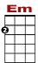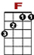
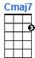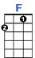

2 2 2 0 0
3 1 1 1 1 1 0 0 0 0 0
0 2

It'd been years since the kids had grown, a life of their own and left us a-lone.

2nd VERSE:

3 3 2 0 0 0 3 3 0 0 0
3 3 3 3 3 3

John and Lin-da live in Om - maha, and Joe is somewhere on the road.

2 2 2 2 0 0
3 3 1 1 1 1 1 1 1 0 0 0 0 0 0
0 2

We lost Davy in the Ko-re-an war, and still don't know what for, don't matter an-ny-more.

REFRAIN:
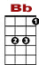
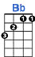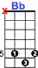

1 1 1 1 3 5 5 3 3 3 1 1 1 1 1 3 5 3

Ya know old trees just grow stron-ger, and old rivers grow wilder ev - ry day.

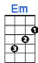

2 2 2 0 0
3 1 1 1 1 1 0 0 0 0 0
0 2 2 0

Old people just grow lonesome, waiting for someone to say, "Hel - lo in there, hel - lo."

3rd VERSE:

Me and Loretta, we don't talk much more. She sits and stares through the back door screen.
And all the news just repeats itself, like some forgotten dream that we've both seen.

4th VERSE:

Someday I'll go and call up Rudy. We worked together at the factory.
But what could I say if he asks "What's new?" Nothing, what's with you? Nothing much to do.

REFRAIN:

Ya know old trees just grow stronger, and old rivers grow wilder ev'ry day.
Old people just grow lonesome, waiting for someone to say, "Hello in there, hello."

5th FINAL VERSE:

So if you're walking down the street sometime and spot some hollow ancient eyes,
Please don't just pass 'em by and stare, as if you didn't care, say, "Hello in there, hello."

