Have You Ever Seen The Rain by Creedence Clearwater Revival

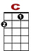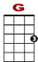
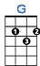
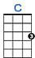

0 0 3 3 3 3 3 1 1 0
0 0 0 0 0 0 0 0 0
0 2 0 2

Someone told me long a – go, there’s a calm be - fore the storm, I know; it’s been com-in for some time.

0 0 3 3 3 3 3 1 1 0
0 0 0 0 0 0 0 0
0 2 0 2

When it’s o - ver, so they say, it’ - ll rain a sun - ny day, I know; shin - in down like wa - ter.

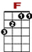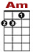
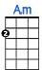
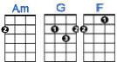
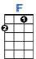

0
3 1 3 0 1 3 3 3
0 0

I want to know, have you ev - er seen the rain?

0
3 1 3 0 1 3 3 3 0
0 0 0 2 2 0 0 0
2

I want to know, have you ev - er seen the rain, com - in down on a sun - ny day?

Yes-ter-day, and days before, sun is cold and
‘Till forev er, on it goes, through the circle, fast and slow, I know; it can’t stop, I wonder.

I want to know, have you ev - er seen the rain?
I want to know, have you ev - er seen the rain, comin down on a sunny day?

Yeah, I want to know, have you ev - er seen the rain?
I want to know, have you ev - er seen the rain, comin down on a sunny day?

