Happy Trails

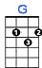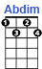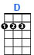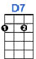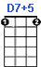

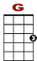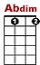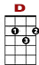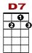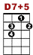

3 3 0 3 3 0
2 2 3
0 0 0 2 0 3 0 4 0 0 0 0 0

Happy trails to you un-til we meet a-gain. Happy trails to you, keep smiling on till then.

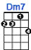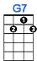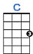

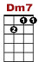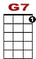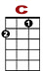

1 1 1 0 0 0 0
0 2 0 0

Who cares about the clouds when we’re to- geth-er,

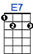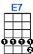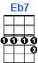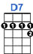

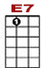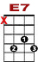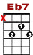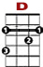

0
0 3 3 0 1 3
0 2 2 1 1 4 3 2 0
4 3 4 0 0 4
Just sing a song and bring the sunny wea - ea - ther. Happy trails to you, till we meet a - gain

