Hallelujah by Leonard Cohen (high verse)

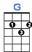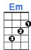

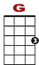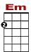

0 0 0 0 0 0 0
3 3 3 3 3 3 3 3 3 3 3

Well I've heard there was a secret chord that David played and it pleased the Lord

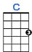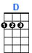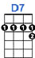

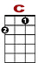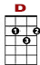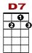

0 0 0 0 0 0
3 3 3 3 3

But you don't really care for music do you?

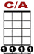

0 0 2 3 3 3 3 3 3 5
3 3 3 3 3 3

It goes like this the fourth the fifth, the minor fall, the major lift

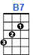

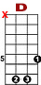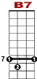

5 5 5 7 7 7 5 3 3
8 8

The baffled king com-posing hal-le-lu-jah.

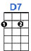

0 0 0 0 0 0
0 3 3 0 0 0 3 3 0
2 0

Halle - lujah, hal - le - lujah. Halle - lujah, hal - le - lu uu jah.

2nd VERSE: Your faith was strong but you needed proof, you saw her bathing on the roof
Her beauty and the moonlight over-threw ya.
She tied you to a kitchen chair, she broke your throne, and she cut your hair
And from your lips she drew the halle-lujah.
Halle - lujah, hal-le - lujah. Halle - lujah, ha-lle - lu uu jah.

3rd VERSE: Well baby I've been here before, I know this room and I've walked this floor,
I used to live alone before I knew ya.
I've seen your flag on the marble arch, but love's not some kind of victory march
No it's a cold and it's a very broken halle-lujah.
Halle - lujah, hal-le - lujah. Halle - lujah, ha-lle - lu uu jah.

4th VERSE: I did my best, but it wasn't much, I couldn't feel so I tried to touch
I've told the truth, I didn't come to fool ya.
And even though it all went wrong, I'll stand before the Lord of Song
With nothing on my tongue but halle-lujah.
Halle - lujah, hal-le - lujah. Halle - lujah, ha-lle - lu uu jah.

