Freight Train

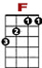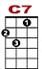

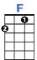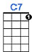
Freight train, freight train, goin' so fast, freight train, freight train, goin' so fast.

3 0 3 1 3 1 3 0
3 1 0 3 0 1

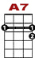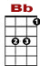

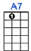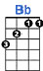
Please don't tell what train I'm on, so they won't know where I'm gone.

0 1 0 0
0 1 3 1 1 3 1 3 0 1

Freight train, freight train, round the bend, freight train, freight train, comin' back again
One of these days turn that train around, and go back to my home town.

One more place I'd like to be, one more place I'd like to see
To watch them old Blue Ridge Mountains climb, when I ride old Number Nine.

When I die Lord, bury me deep, down at the end of Chestnut Street
Where I can hear old Number Nine, as she comes down the line.

Freight train, freight train, goin' so fast, freight train, freight train, goin' so fast
Please don't tell what train I'm on, so they won't know where I'm gone.

