Four Strong Winds written by Ian Tyson and performed by Ian and Sylvia

REFRAIN:
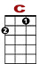
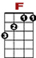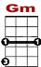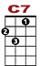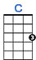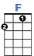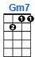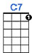

1 1 0 1 0 1 3
0 2 2 2 2 0

Four strong winds that blow lone-ly, Se-ven seas that run high,

1 1 0 1 0
0 2 2 2

All those things that don't change come what may.

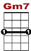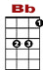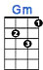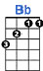
0 0 0 1 1 1
1 3 3 1 1 0 0 1 3 3 1 1 1 1
2 2 0 2 0

But our good times are all gone. And I'm bound for mo-ving on. I'll look for you if I'm ev-er back this way.
1st VERSE:

1 1 1 0 1 0 1 1 3
0 2 2 2 2 0

Think I'll go out to Al-ber-ta. Weat-her's good there in the fall.

1 1 1 0 1 0
0 0 2 2 2 2

I got some friends that I can go to work-ing for.

0 0
1 3 3 1 1 0 0 1 3
2 2 0

Still I wish you'd change your mind, if I asked you one more time.

0 1 1 1
3 3 1 1 1
2 0

But we've been through that a hundred times or more.

REFRAIN:

2nd VERSE: If I get there before the snow flies and if things are goin' good,
You could meet me if I sent you down the fare.
But by then it would be winter. There ain't too much for you to do.
And those winds sure can blow cold way out there.
REFRAIN:

