Fire and Rain by James Taylor

Verse 1:
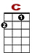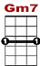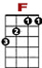
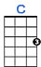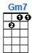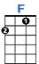
0
0 0 0 0 1 1 1 1 1 3 1 3

Just yesterday morning they let me know you were gone.

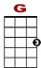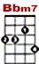
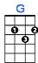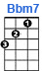

0 3 0 3 3 3 1 0 1 0
2

Susanne, the plans they made put an end to you.

0
0 0 0 0 1 1 1 1 3 1 3 0 3 3 3 3 3 1 0 1 0
2

I walked out this morning and I wrote down this song. I just can’t remember who to send it to.

Chorus:
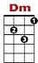
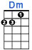

0 0 0 0 0 0 0 0 0 0 0
3 1 3 0 3 3 1 3

I’ve seen fire and I’ve seen rain. I’ve seen sunny days that I thought would never end.

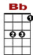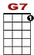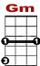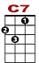
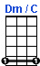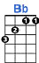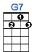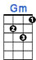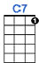

0 0 0 2 3 5 3 2 0
0 3 8 7 5 3 0 0 1 1 1 1 1 1 1 3

I saw lonely times when I could not find a friend. But I always thought I’d see you a-gain

Verse 2:

Won’t you look down upon me Jesus you got to help me make a stand.
You just got to see me through another day.
My body’s aching and my time is at hand. An' I won’t make it any other way.

Chorus

Verse 3:

Been walking my mind to an easy time. My back turned towards the sun.
Lord knows when the cold wind blows it’ll turn you head around.

Chorus

Verse 4:

Well there's hours of time on the telephone line, to talk ‘bout things to come.
Sweet dreams and flying machines in pieces on the ground.

Chorus

