Every Breath You Take by The Police

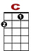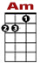
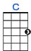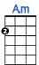
Every breath you take and every move you make.

0 1 0 0 0 1 0
2 0 2 0

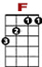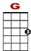
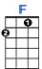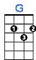
Every bond you break every step you take, I'll be watching you.

0 1 1 0 0
0 0 0 0 0 2 2 0 0 0

Every single day and every word you say,

Every game you play every night you stay, I'll be watching you.

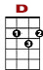
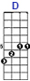
Oh can't you see you belong to me? How my poor heart aches with every step you take.

0 0 0 3 3 3 3 5 5 5
0 3 3 0 5 8 5 3
0 0

Every move you make every vow you break.

Every smile you fake every claim you stake, I'll be watching you.

Every smile you fake every claim you stake, I'll be watching you.

