Easy by Lionel Richie

1st VERSE:
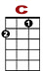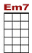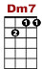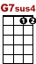

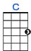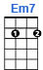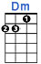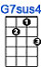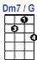

0 0 0 0 0 0 0 0 3 0
2 0 0 2 0 0 2 0
2 2
Know it sounds funny but I just can't stand the pain; girl, I'm leaving you to mor row.

0 0 0 0 0 0 0 0 3 0
2 0 2 0 0 0 2 0
2 2
Seems to me girl you know I've done all I can. You see I begged, stole and I borrowed.

CHORUS:

0 0 0 0
0 2 2 0 2
0 2 0 2
That's why I'm ea - sy. I'm easy like Sunday mor - ning

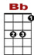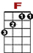
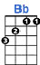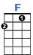

3 2 0
3 0 0 0
0 2 2 0 2 0 0
0 2 0 2
That's why I'm ea------------------sy. I'm easy like Sunday morn------------------ing

2nd VERSE: Why in the world would anybody put chains on me? I've paid my dues to make it
Everybody wants me to be what they want me to be. I'm not happy when I try to fake it.

CHORUS: That's why I'm easy. I'm easy like Sunday morning. That's why I'm easy. I'm easy like Sunday morning

BRIDGE:

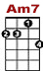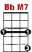
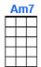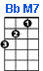

0 0 1 0 1 0 1 0
0 3 3 0 0 3 1 3
0 0 0 0

I wanna be high, so high I wanna be free to know the things I do are right

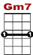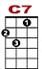
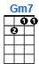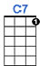

0 3 0 0 0
3 0 0
0 2

I wanna be free, just me, oo - oh babe.

CHORUS: That's why I'm easy. I'm easy like Sunday morning. That's why I'm easy. I'm easy like Sunday morning

