Don't Get Around Much Anymore by Bob Russell/Duke Ellington

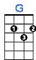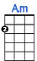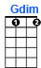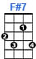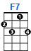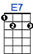
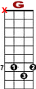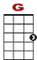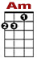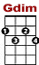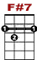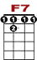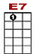

7 7
10 8 3 1 0 10 8 3 1 0

Missed the Saturday dance. Heard they crowded the floor.

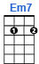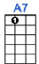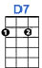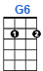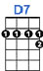
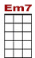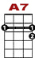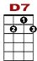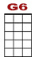
3 0
3 1 0 0 1 2 3 0
2 0 0 3 0
Couldn't bear it without you. Don't get around much anymore.

7 7
10 8 3 1 0 10 8 3 1 0

Thought I'd visit the club. Got as far as the door.

3 0
3 1 0 0 1 2 3 0
2 0 0 3 0

They'd have asked me about you. Don't get around much anymore.

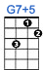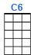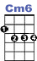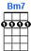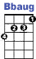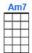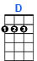
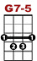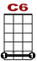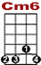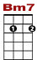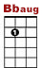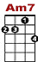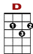

3 5 5 5 5 5 3 2 0 0 3 2
8 5 8 5 8 8 5 3
7
Oh, Darling, I guess my mind's more at ease. But nev-ver-the-less, why stir up mem – mor - ries.

7 7
10 8 3 1 0 10 8 3 1 0

Been invited on dates. Might have gone but what for?

3 0
3 1 0 0 1 2 3 0
2 0 0 3 0

Awfully different without you. Don't get around much anymore

