Don't Fence Me In by Cole Porter

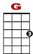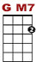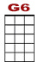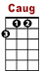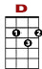
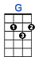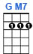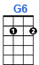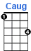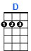

0 2 2 0 2 2 0 2 0 0 2 2 3 2 0
3 3 3

Oh give me land lots of land under starry skies above. Don't fence me in.

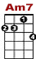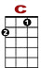
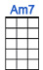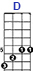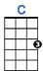

0 0 0 0 0 0 0 0 5 5 3 2
2 3 3 2 3

Let me ride through the wide open spa-ces that I love. Don't fence me in.

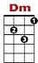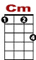
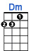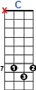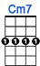

0 2 2 2 2 2 2 2 2 0 3 3 3 3 3 3 3 5 7 7 7 5 3
3 3

Let me be by myself in the evening bre – zes. Listen to the murmur of the cottonwood trees.

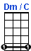

2 0 2 3 5 5 6 7 7 5 3 2 2 0
9 3

Send me off for-ev-ver but I ask you please. Don't fence me in.

0
3 3 3 3 0 2 3 2 0 2 3 2 0 2 3 3 0
2

Just turn me loose, let me straddle my old saddle underneath the western skies.

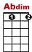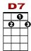
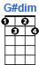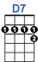

0
3 3 3 3 0 2 3 2 0 2 3 2 0 2 3 3 0
2

On my Ca- yoose, let me wander o-ver yonder where the purple mountains rise.

0 2 2 2 2 2 2 2 2 0 3 3 3 3 3 5 7 7 5 3
3 3
2

I want to ride to the ridge when the west commen – ces. Gaze at the moon 'til I lose my sen-ses.

2 2 3 5 5 6 7 7 5 3 2 2 0
9 3

Can't look at hobbles and I can't stand fen-ces. Don't fence me in.

