Desperado by The Eagles

CHORUS:
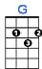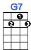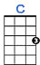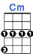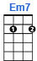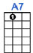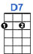
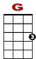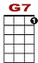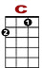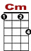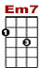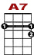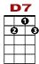
0
0 0 0 3 0 3 0
2 2 0 2 0 0 2 0 0 0 0 2 2
2 2
Des-per-ra-do, why don't you come to your sen-ses? You been out ri-din' fen-ces for so long now.

0 0 3 0
2 0 2 0 0 2 0
2 2
Oh, you're a hard one, I know that you got your rea-sons,

0
0 3 0 3 0 0
0 0 2 2 0

These things that are plea-sin' you can hurt you some how.

1st VERSE:
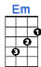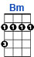
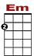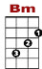
0 0 0 0
3 1 0 1 1 0
0 0 4 4 4 0

Don't you draw the queen of dia-monds boy, she'll beat you if she's a-ble,

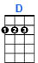
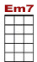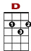

0 0 1 0 1 0 3 0
0 0 0 0

You know the queen of hearts is al-ways your best bet.

0 0 2 0 0
3 1 1 3 3 0 0 0
0 0 4 4 4 0 0 0 0 0 2 3 2
2
Now it seems to me some fine things have been laid u-pon your ta-ble. But you on-ly want the ones that you can't get.

CHORUS: Desperado, oh you ain't gettin' no younger, Your pain and your hunger, they're drivin' you home.
And freedom, well, that's just some people talkin'. Your prison is walkin' through this world all alone.

2nd VERSE: Don't your feet get cold in the winter time? The sky won't snow and the sun won't shine.
It's hard to tell the night time from the day. You're losin' all your highs and lows. Ain't it funny how the feelin' goes away?

CHORUS AND ENDING:
0
0 0 0 3 0 3 0
2 2 0 2 0 0 2 0 0 2 0 2
2 2
Des per a do, why don't you come to your sen-ses? Come down from your fen-ces, o-pen the gate.

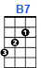
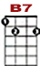

0 0 3 0 0 3 0
2 0 2 0 0 2 0 0 0 0 2 2 0
2 2
It may be rain-in', but there's a rain-bow a-bove you, you bet-ter let some-bo-dy love you,

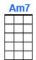
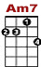

0 3 0 0 0
0 0 0 2 0 0 2 2 0

You bet-ter let some-bo-dy love you be-fore it's too late.

