Crazy by Willie Nelson

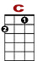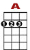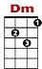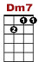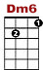
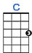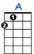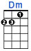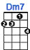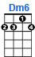
Crazy, I'm crazy for feeling so lonely.

0 0
0 0 3 0 1
1
0 0 2
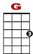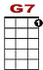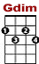
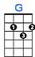 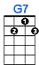 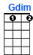
I'm crazy, crazy for feeling so blue.

0
3 1 0 0
2 2
0 0 4
I knew you'd love me as long as you wanted.
0 0
0 0 3 0 1
1
0 0 2

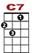
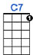
And then someday you'd leave me for somebody new
0 0
3 1 0
2 2 0
0 0 0 4

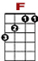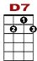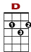
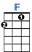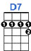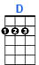
Worry, why do I let myself worry? Wond'ring what in the world did I do?

3 0 0 3 2 0 3 3 0 0 3 2 0
1 3 2 3
0 2

Crazy for thinking that my love could hold you.

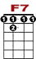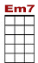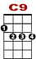
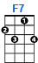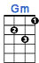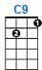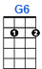
I'm crazy for trying and crazy for cry - ing, and I'm crazy for lov – ing you.

0 3 0 3 2 0 0
3 3 1 3 0 0 0 1 1 1 0
2 0

