Bye Bye Blackbird by Mort Dixon and Ray Henderson

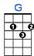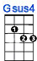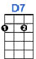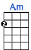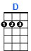

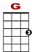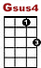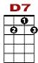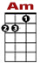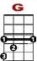

0 0 0 0 1 0 0 0
2 2 2 0 0 0 2 0
4
Pack up all my cares and woes, here I go sin-gin’ low, bye, bye black-bird.

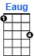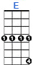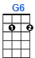

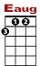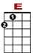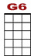

1 1 1 1 3 1 1 1 0 0 0 0
2 2 2 2 0

Where somebody waits for me, sugar’s sweet, so is she, bye bye blackbird.

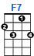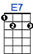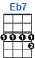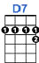

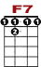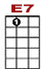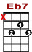

3 3 3 3 1 0 0 1 0 1 1 1 0
0 2 0 3 2
2
No one here to love and un-der-stand me. Oh what hard luck stories they all hand me

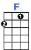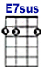

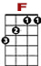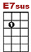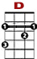

0 0 0 0 1 0 0 0 0 1
2 2 2 1 2 0
4
Make my bed and light the light, I’ll a-rrive late to - night. Blackbird, bye bye.

